**EX.NO:4 SQL FUNCTIONS**

# AIM

To study the various SQL Functions operations on the database.

## DESCRIPTION:

## What are functions?

Functions are methods used to perform [data operations](https://www.edureka.co/blog/sql-operators/). SQL has many in-built functions used to perform string concatenations, mathematical calculations etc.

SQL functions are categorized into the following two categories:

1. Aggregate Functions
2. Scalar Functions

Let us look into each one of them, one by one.

## AGGREGATE SQL FUNCTIONS

The Aggregate Functions in SQL perform calculations on a group of values and then return a single value. Following are a few of the most commonly used Aggregate Functions:

|  |  |
| --- | --- |
| **Function** | **Description** |
| SUM() | Used to return the sum of a group of values. |
| COUNT() | Returns the number of rows either based on a condition, or without a condition. |
| AVG() | Used to calculate the average value of a numeric column. |
| MIN() | This function returns the minimum value of a column. |
| MAX() | Returns a maximum value of a column. |
| FIRST() | Used to return the first value of the column. |
| LAST() | This function returns the last value of the column. |

## SCALAR SQL FUNCTIONS

The Scalar Functions in SQL are used to return a single value from the given input value.  Following are a few of the most commonly used Aggregate Functions:

|  |  |
| --- | --- |
| **Function** | **Description** |
| LCASE() | Used to convert string column values to lowercase |
| UCASE() | This function is used to convert a string column values to Uppercase. |
| LEN() | Returns the length of the text values in the column. |
| MID() | Extracts substrings in SQL from column values having String data type. |
| ROUND() | Rounds off a numeric value to the nearest integer. |
| NOW() | This function is used to return the current system date and time. |
| FORMAT() | Used to format how a field must be displayed. |

**EXAMPLE:**

**CHARACTER/STRING FUNCTION:**

SQL> select upper('welcome') from dual;

SQL> select upper('hai') from dual;

SQL> select lower('HAI') from dual;

SQL> select initcap(‘hello world') from dual;

SQL> select ltrim('hello world',’hell’) from dual;

SQL> select rtrim(''hello world',’ld’')from dual;

SQL> select concat('SRM',' University')from dual;

SQL> select length('Welcome’) from dual;

SQL> select replace('SRM University', 'University','IST')from dual;

SQL> select lpad('SRM University',20,'*')from dual;

SQL> select rpad('SRM University',15,'$')from dual;

SQL> select substr('Welcome to SRM University', 4,7)from dual;

SQL> select replace('COMPUTER','O','AB')from dual;

SQL> select replace('University','city’,'Inter')from dual;

SQL> select translate('cold','ld','ol')from dual;

**OUTPUT:**

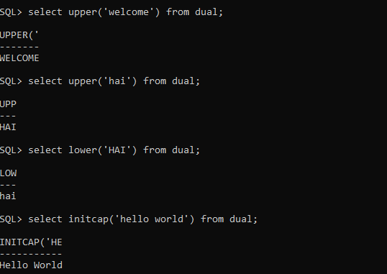

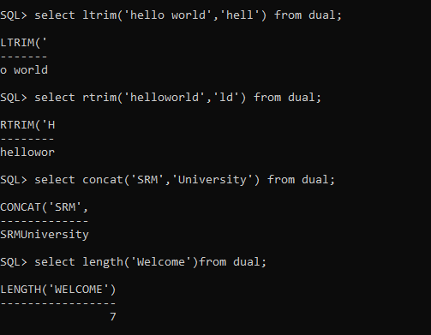

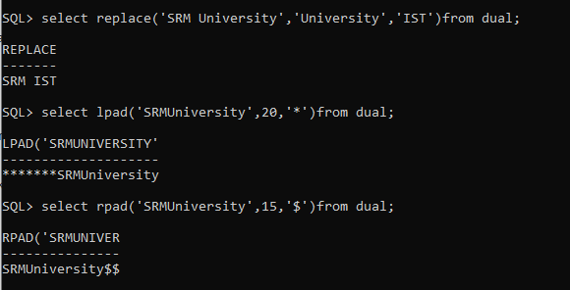

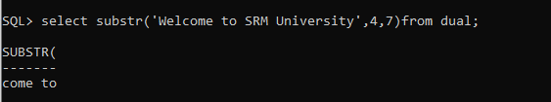

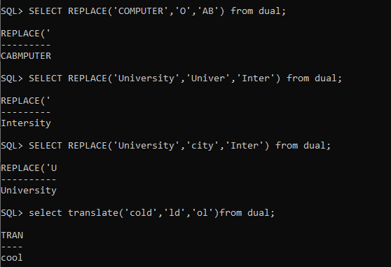

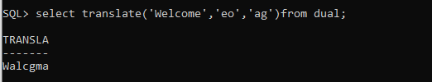

**DATE & TIME FUNCTION**

SQL> select sysdate from dual;

SQL> select round(sysdate)from dual;

SQL> select add_months(sysdate,3)from dual;

SQL> select last_day(sysdate)from dual;

SQL> select sysdate+20 from dual;

SQL> select next_day(sysdate,'tuesday')from dual;

**OUTPUT:**

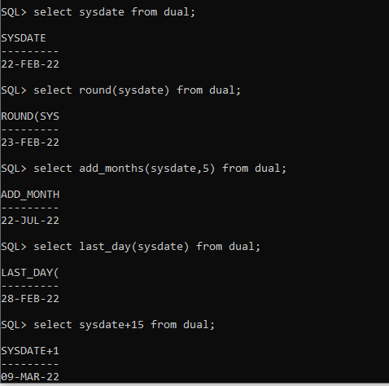

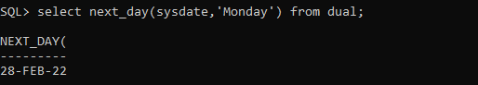

**NUMERIC FUNCTION**

SQL> select round(15.6789)from dual;

SQL> select ceil(23.20)from dual;

SQL> select floor(34.56)from dual;

SQL> select trunc(15.56743)from dual;

SQL> select sign(-345)from dual;

SQL> select abs(-70)from dual;

**OUTPUT:**

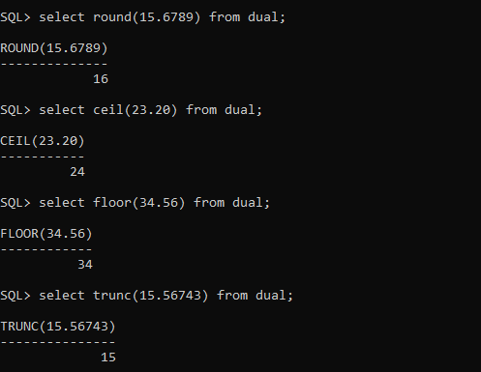

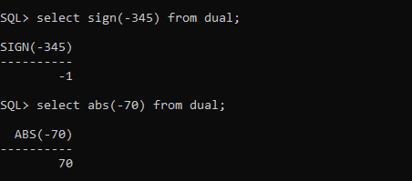

**MATH FUNCTION:**

SQL> select power(10,12) from dual;

SQL> select power(5,6) from dual;

SQL> select mod(11,5) from dual;

SQL> select exp(10) from dual;

SQL> select sqrt(225) from dual;

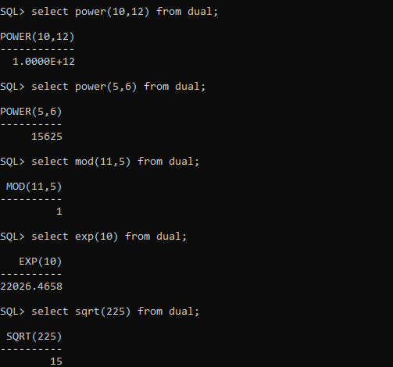

# RESULT:

Thus the SQL Functions have been executed successfully.